David Cleveland
BCS Rankings

Coaches Poll:
- 62 voters, each ranks teams 1-25
- A team receives 25 points for a rank of 1, 24 for a rank of 2, etc.
- The perfect number of points a team can receive is 1550

EXAMPLE: Michigan receives the following votes: 5, 6, 7, 4, 7, 8, 8, 4, 4, 5,6, 7, 7, 7, 8, 5, 4, 3, 3, 5, 6, 6, 7, 6, 7, 5, 5, 5, 4, 4, 7, 7, 7, 5, 5, 5, 4, 4, 6, 5, 5, 5, 5, 5, 5, 7, 7, 7, 4, 4, 4, 4, 4, 4, 5, 5, 5, 5, 7, 7, 6, 6
So the total number of each rank they received is:
3: 2 x23 points= 46
4: 14 x 22 points= 308
5: 20 x 21 points=420
6: 8 x 20 points = 160
7: 15 x 19 points=285
8: 3 x 18 points= 54

46+308+430+160+285+54= 1283 = .8277 is the ranking Michigan receives
1550 1550 in the Coaches Poll

Harris Poll:
- 105 voters rank teams 1-25
- The point system is the same point system as the coaches poll
- The total number of points a team can receive is 2625

EXAMPLE: USC receives the following rankings from the Harris Poll:

21: 35 x 5 points=175
22: 43 x 4 points=172
23: 20 x 3 points=60
24: 3 x 2 points=6
25: 4 x 1 point=4

175+172+60+6+4= 417= .1589 So this Gives USC a ranking of .1589 in the
2625 2625 Harris Poll. A number like this usually leaves a
team within the 20-25 rank.

Computer Rankings:
- Made up of six different computer rankings (Sagarin Ratings, Anderson and Hester, Richard Billingsley, Colley Matrix, Massey Ratings, Peter Wolfe)
- The point system is the same as both the Harris and the Coaches Poll (25 for 1st, 24 for 2nd, etc.)
- The lowest and highest computer rankings for each team are thrown out
- The remaining points are added together, and divided by 100, which is the number of points a team would have if they were ranked #1 on the remaining 4 computer rankings
- The exact methodology behind specific computer polls is sometimes a guarded secret

Colley Rankings
- One of the owners of the six computer rankings uses many formulas in determining the ranks of each of the different teams
- He is the only one that reveals how he does his rankings
- Colley uses a combination of linear algebra, probability and integral calculus in determining the rank of a team
- There are many formulas in his ranking system, but the main formulas involve winning percentage and a system of equations/matrix
- One difference between regular rankings and the Colley Rankings are how he determines win percentage

R = 1+Nw Nw is the number of wins, Ntot
2+Ntot is the number of games played
This can also be written as: R = 1+Nw
2+Nw+Nl with Nl=the number of losses

- Colley also uses a Matrix method in order to determine his rankings with the following formulas (rW is the team with a 1-0 record, rL i0-1):

rW= 1+(1/2)+rL rL=1-(1/2)+rW
2+1 2+1

Which is then rearranged to 3rW-rL=3/2
-rW+3rL=1/2
- After it is put in a matrix, you get 5/8 for the winner and 3/8 for the loser.

- The following is using a matrix with a 5-team field

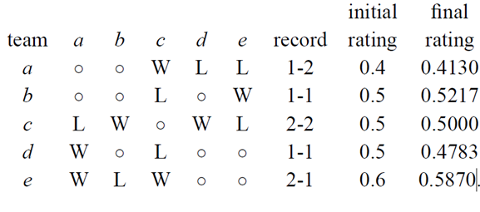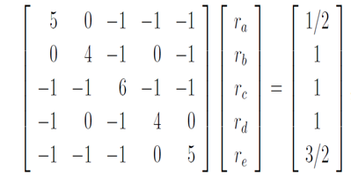
Which reduces to:
1 0 0 0 0 19 /46
0 1 0 0 0 12/23
0 0 1 0 0 1 /2
0 0 0 1 0 11/23
0 0 0 0 1 27/46

BCS Rank
Each of the three rankings received from the Harris Poll, The Coaches Poll and the Computer Rankings are added together and divided by three.

EXAMPLE:
Alabama receives a score of .9546 from the Harris, .9766 from the Coaches and .9880 from the Computer rankings.
.9546 + .9766 +.9880 = 2.9192 = .9730
3 3

